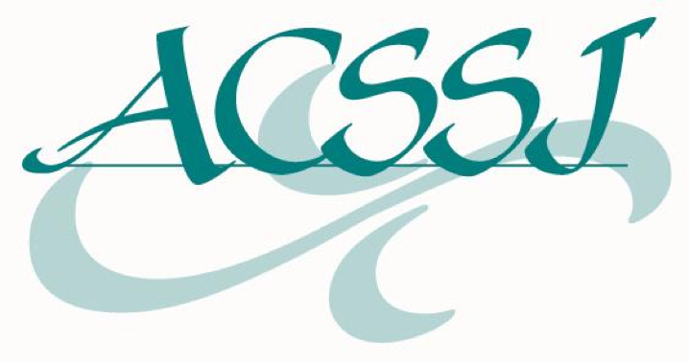
Four Member Campuses of
The Association of Colleges of Sisters of St. Joseph
Receive Mini-Grants to Participate
in National Catholic Sisters Week

The Association of Colleges of Sisters of St. Joseph (ACSSJ) has awarded four member campuses mini-grants. “The Association of Colleges of Sisters of St. Joseph is pleased to join 41 others nationwide in celebrating National Catholic Sisters Week. The mini-grants will allow campuses to share the current and past contributions of the Sisters of St. Joseph in creating a more just community through advocacy on sustainable development, human rights, public health and immigration,” said Martha Malinski, Executive Director of the Association of Colleges of Sisters of St. Joseph.

Grantees identified programming that highlight the work and impact of the Sisters in local, national and international politics.

- Avila University will host Sister Justine Gitanjali Senapati, CSJ on Tuesday, March 8. She will present on her life as an Indigenous Indian Sister of St. Joseph, as the UN-NGO representative for the global CSJ community, and on our role as a CSJ university in advocating for sustainable development and human rights across the globe. Her program is organized by the CSJ Center for Heritage, Spirituality & Service and the Center for Global Studies & Social Justice.

- Chestnut Hill College will host “Beyond Borders: Mission at the Heart of Immigration and Advocacy” with Sister Veronica Roche, SSJ. Associate Professor of Religious Studies, Sister Mary Kay Flannery, SSJ, D.Minn will give the response. The talk will occur on March 14 and be the kick-off event of St. Joseph’s week. The talk is sponsored by Campus Ministry.

- Mount Saint Mary’s University, Los Angeles will celebrate National Catholic Sisters Week and Sisters of St. Joseph of Carondelet Week March 13th – 19th with several events, beginning with an Open House on March 13th at the Carondelet Center, provincial motherhouse to the Los Angeles province of the CSJs of Carondelet. In honor of our Sisters’ scholarship and contribution to the common good, we will exhibit a new display showcasing the research of Sr. Mary Gerald Leahy CSJ, a microbiologist whose studies in the 1960s and 70s have direct impact on current research into the mosquitos carrying the Zika virus. Campus Ministry, the University Archives and the new CSJ Institute are collaborating on this effort. This event is part of a larger week of celebration including St. Joseph’s Day Mass and reception, CSJ Appreciation Day, and the Sisters of St. Joseph of Carondelet, Los Angeles Jubilee celebration.

- St. Catherine University will host “Habits and Hi-Jab” on March 10. Panelists will discuss the history of the Sisters of St. Joseph of Carondelet wearing the habit and provide reflections on the experience of Muslim students wearing the Hi-jab. The program is an opportunity to learn about each other’s communities (past and present) in order to be better allies and find the similarities as well as honoring differences. Part of the motivation is for the Sisters of St. Joseph of Carondelet and consociates to show support and solidarity for our Muslim students and community members in the Twin Cities in this time of heightened sensitivity and Islamophobia. Sponsors include- Sisters of St. Joseph St. Paul Province’s Dismantling Racism Working Group, Multicultural and International Programs and Services, Muslim Student Association and Campus Ministry.

About National Catholic Sisters Week
National Catholic Sisters Week is an annual celebration that takes place from March 8–14. Created to honor women religious, it is a series of events that instruct, enlighten, and bring greater focus to the lives of these incredible women. It’s our chance to recognize all they have done for us. National Catholic Sisters Week is supported by a $3.3 million grant from the Conrad N. Hilton Foundation, is headquartered at St. Catherine University in St. Paul, Minn., and is held in conjunction with National Women’s History Month. To find out more, visit http://www.nationalcatholicsistersweek.org/

About the Association of Colleges of Sisters of St. Joseph
The Association of Colleges of Sisters of St. Joseph (ACSSJ) draws together nine colleges and universities founded by the Sisters of St. Joseph to articulate and further the contemporary expression of the educational mission and legacy of the Sisters of St. Joseph. The Association fosters collaboration among all the member institutions, provides resources for the faculty, staff and students and encourages mission integration on each campus.

The Association of Colleges of Sisters of St. Joseph includes the following campuses: Avila University (Kansas City, MO), Chestnut Hill College (Philadelphia, PA), Fontbonne University (St. Louis, MO), Mount Saint Mary’s University (Los Angeles, CA), Our Lady of the Elms College (Chicopee, MA), Regis College (Weston, MA), St. Catherine University (St. Paul, MN), St. Joseph’s College (Brooklyn and Long Island, NY) and The College of Saint Rose (Albany, NY). The Association brings together campuses that were founded by the Sisters of St. Joseph and have over 115 years of experience in educating students. The institutions educate nearly 20,000 students annually.

For more information, contact Martha Malinski, Executive Director, Association of Colleges of Sisters of St. Joseph at acssj1@gmail.com or 612-203-3942.

